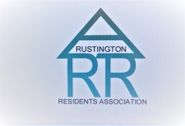

RUSTINGTON RESIDENTS ASSOCIATION
OPEN MEETING
2pm SATURDAY 25th JULY 2026
THE METHODIST CHURCH HALL
CLAIGMAR ROAD RUSTINGTON

Peter Power
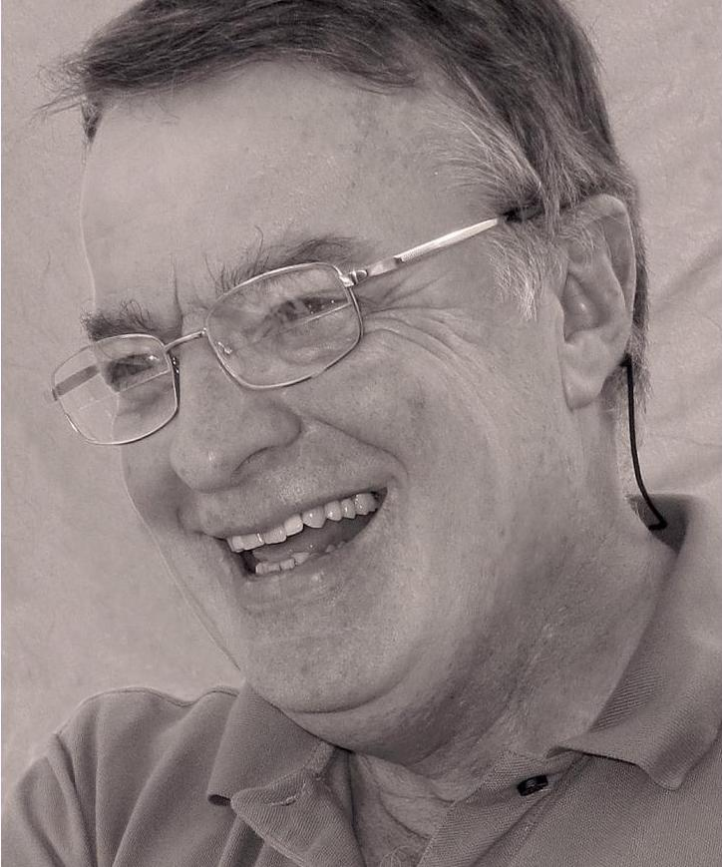

Characters, Courage and Calamities
The brave male agents of the
Special Operations Executive in WW2

Peter will also be talking about a secretive squad known as the Special Wireless Service which was based in Rustington in connection with D Day

Everyone Welcome
Entrance: Members £2.50 Non-Members £3.00
Includes a cuppa

